DAY - 4

Document Version: 1.0

Date: 29/01/2026

DAY: THURSDAY

Prepared By: Testing & Documentation Team

UI COMPONENTS TEAM:

MODULE 5: TIME TRACKING

Introduction:
Time tracking in UI components involves measuring the time users spend interacting with different interface elements. It helps analyze user behavior, evaluate performance, and improve the overall user experience.
SCREENSHOT: PENDING
Description: PENDING

MODULE 6: COLLABRATION & COMMUNICATION

Introduction:
Collaboration and communication in UI components enable users to interact, share information, and work together within an application. These components support features such as messaging, notifications, shared views, and real-time updates, helping improve teamwork, coordination, and overall user engagement.
SCREENSHOT: PENDING
Description: PENDING

DASHBOARD DEVELOPMENT TEAM:

MODULE 2: PROJECT MANAGEMENT

Introduction:
Project management in dashboard development involves planning, organizing, and monitoring tasks to ensure the project is completed on time and meets requirements. The dashboard helps track progress, manage resources, and provide a clear overview of project activities.
SCREENSHOT: 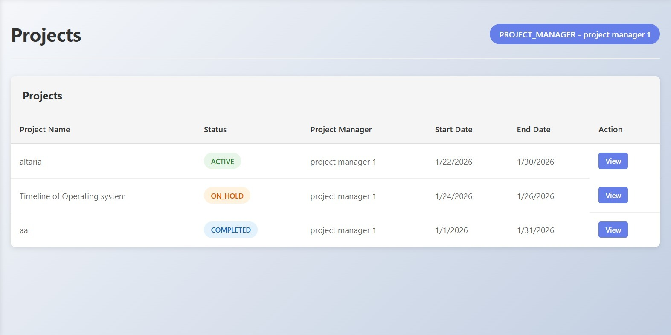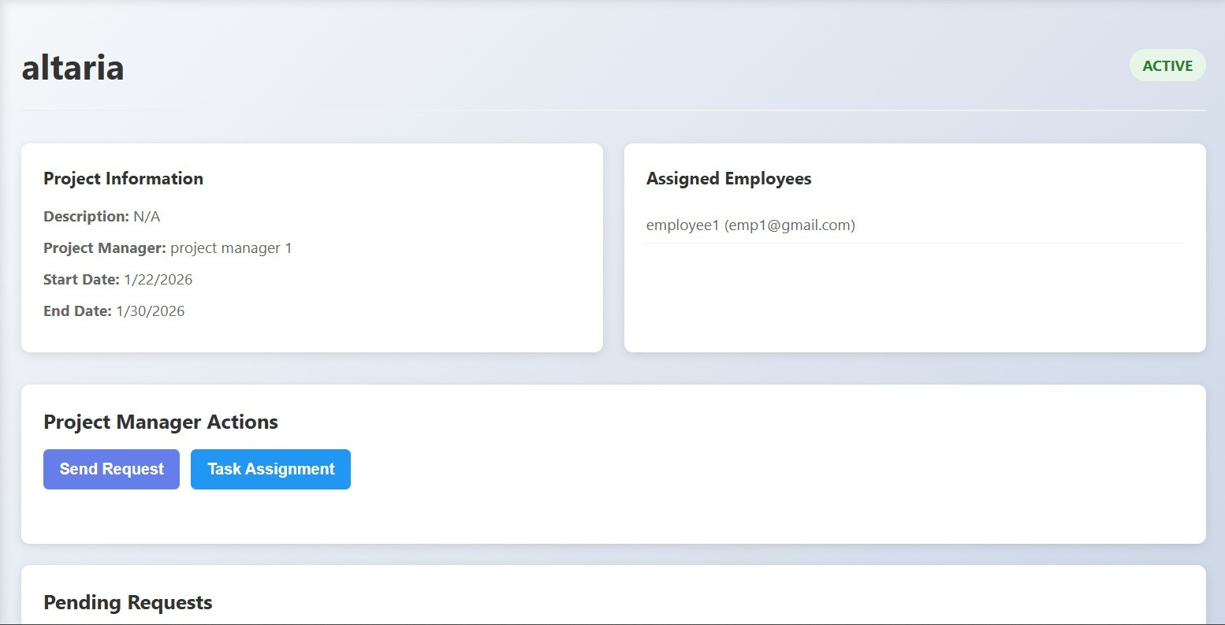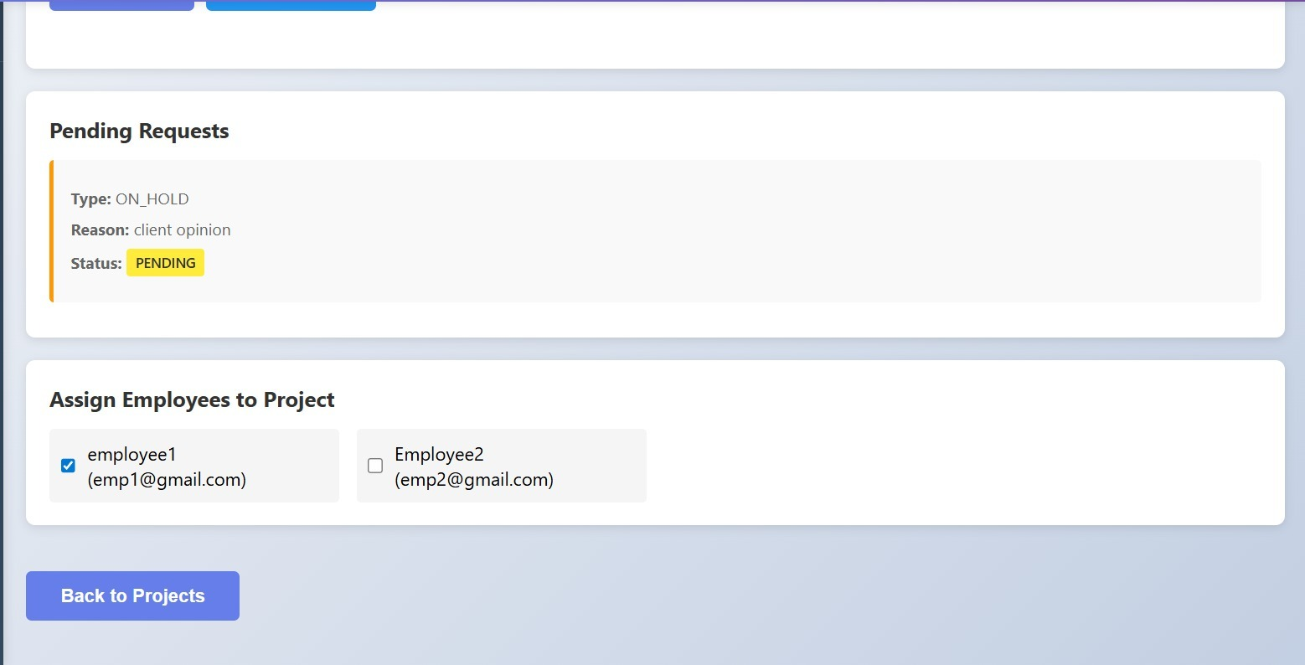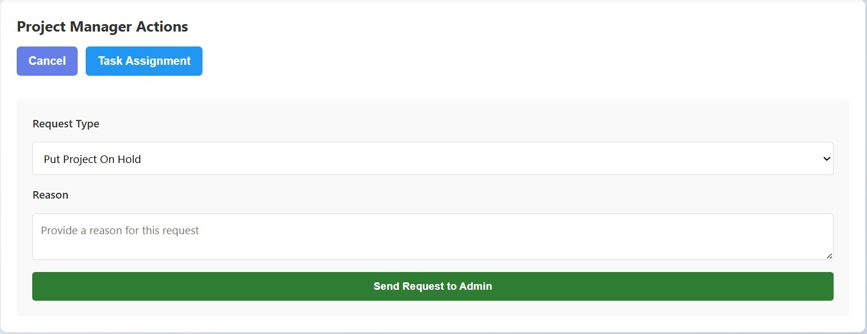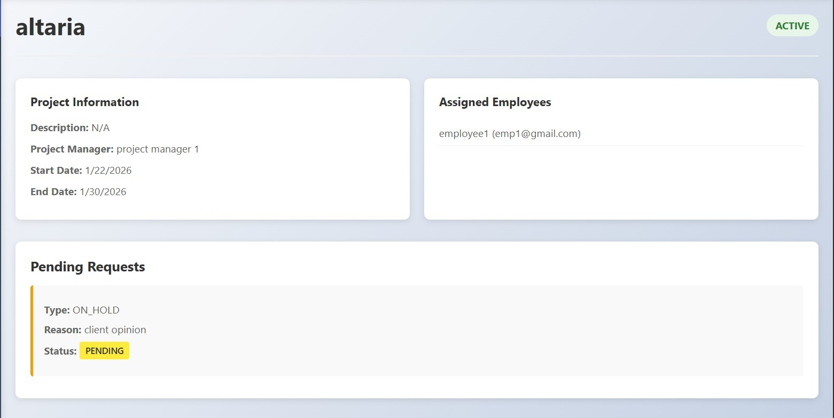
Description:
Project Manager & Employee View
Projects assigned by the admin are displayed for the project manager.
Project managers can manage their projects and assign employees to them.
Project managers can send project requests to the admin for approval.
Employees can view the projects that are assigned to them.

MODULE 4: MILESTONE & PHASES

Introduction:
Milestones and phases in dashboard development represent key stages and important goals of the project. They help track progress, organize work, and ensure the project moves forward in a planned and structured manner.
SCREENSHOT: PENDING
Description: PENDING

TASK MANAGEMENT TEAM:

MODULE 7: ISSUE & BUG TRACKING:

Introduction:
Issue and bug tracking in task management involves identifying, recording, and resolving problems that occur during project execution. It helps teams monitor issues, assign responsibilities, and ensure timely fixes for smooth project progress.
SCREENSHOT: PENDING
Description: PENDING

MODULE 12: DASHBOARD VIEWS

Introduction:
Dashboard views in task management provide a clear and organized display of tasks, progress, and status updates. They help users quickly understand project information and manage work efficiently.
SCREENSHOT: 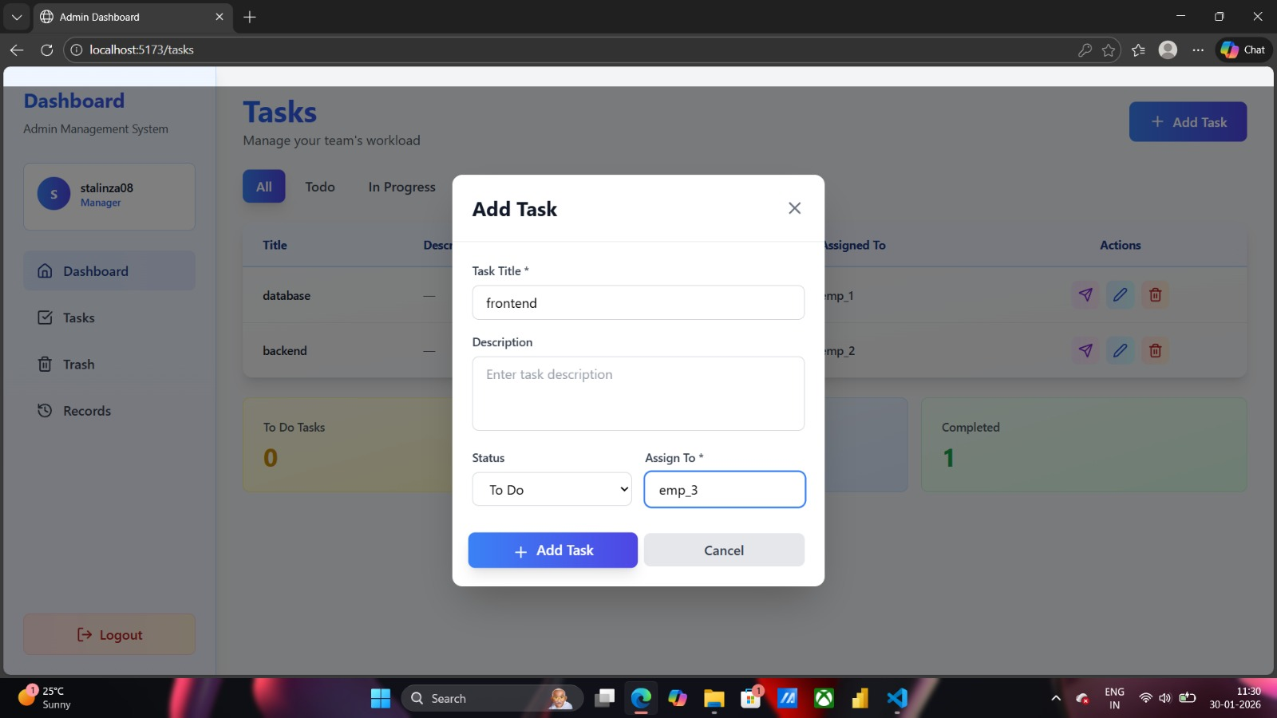
Description: Task Creation & Assignment
A frontend development task was created and assigned to Employee 3. The task was successfully added to the To-Do list for tracking through the Task Management Dashboard
Features:
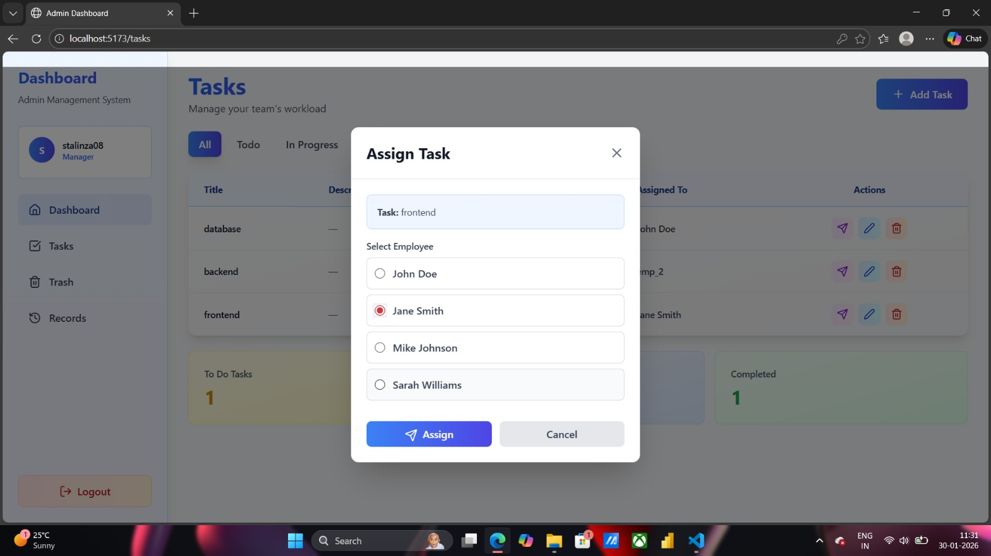

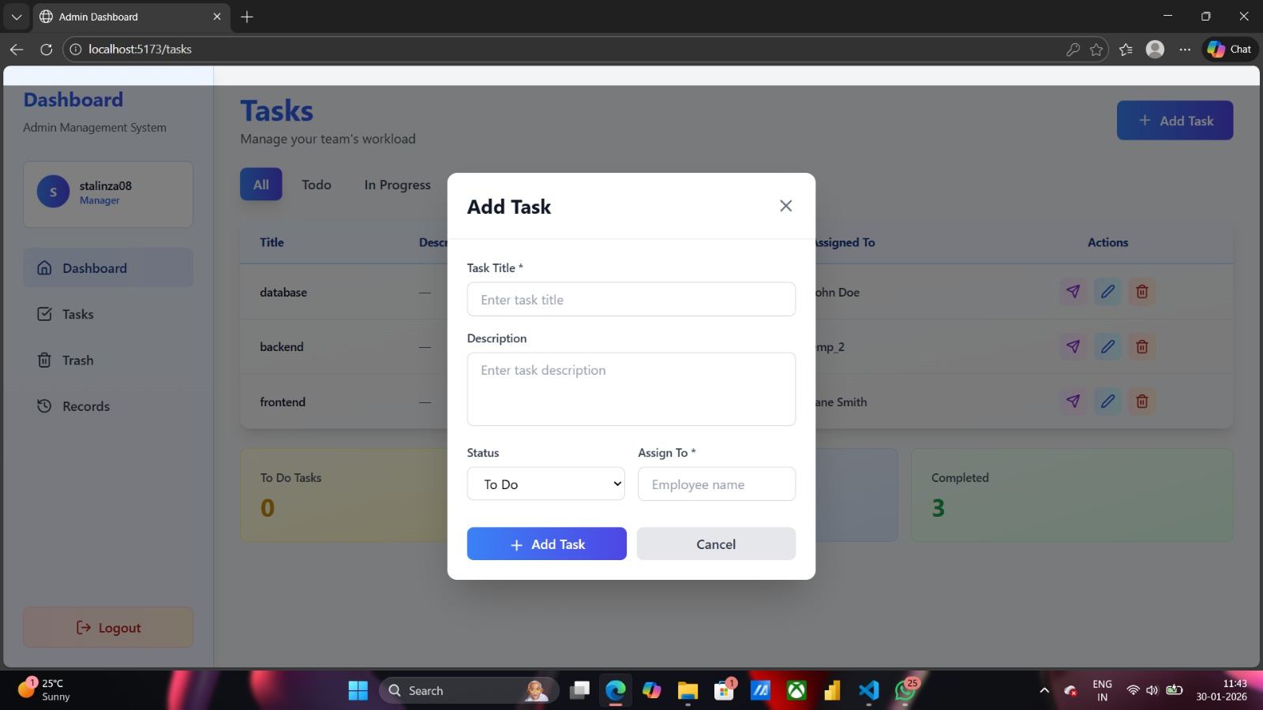

This panel allows administrators to create individual tasks and assign them to specific employees. Tasks can be defined with required details and directly allocated to employees, enabling clear responsibility assignment and efficient task tracking within the system.

ANALYTICS & REPORT TEAM:

MODULE 9: REPORT & ANALYTICS:

Introduction:
Reports and analytics provide meaningful insights by collecting and analyzing project data. They help track performance, identify trends, and support better decision-making through clear visual and statistical information.
SCREENSHOT: PENDING
Description: PENDING

MODULE 10: NOTIFICATION & ALERTS

Introduction:
Notifications and alerts in analytics and reports inform users about important updates, changes, or critical events. They help ensure timely awareness and quick action based on data insights.
SCREENSHOT: PENDING
Description: PENDING

DESIGN & UX TEAM:

MODULE 1: AUTHENTICATION & ORGANIZATION:

Introduction:
Authentication and organization setup in design and UX ensure secure access and proper user management within the application. They help users sign in safely, define roles, and organize teams for a smooth and consistent user experience.

SCREENSHOT: 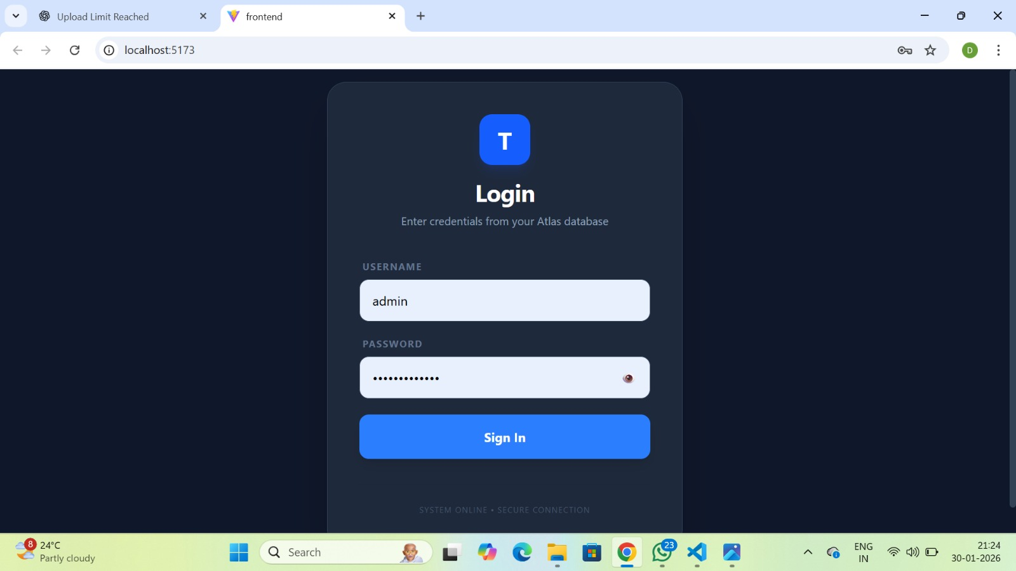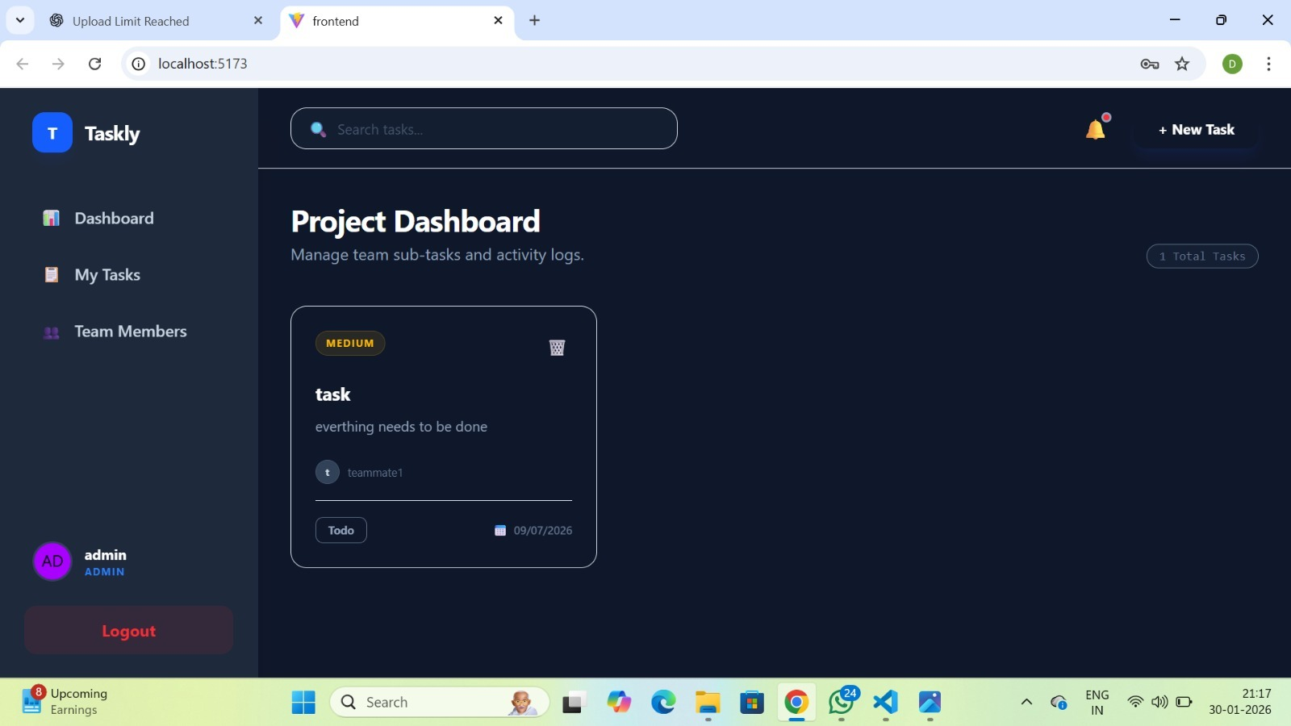
Description:
Completed authentication by implementing JWT-based login. Tokens are generated on successful login and used to manage user sessions. Added role-based access control to redirect admins and teammates to their respective dashboards. Secured backend routes by verifying JWTs, ensuring only authorized users can access protected resources.

MODULE 10: TASK MANAGEMENT

Introduction:
Task management in design and UX focuses on organizing, assigning, and tracking tasks in a user-friendly manner. It helps users plan work efficiently and ensures a smooth and intuitive experience.
SCREENSHOT: 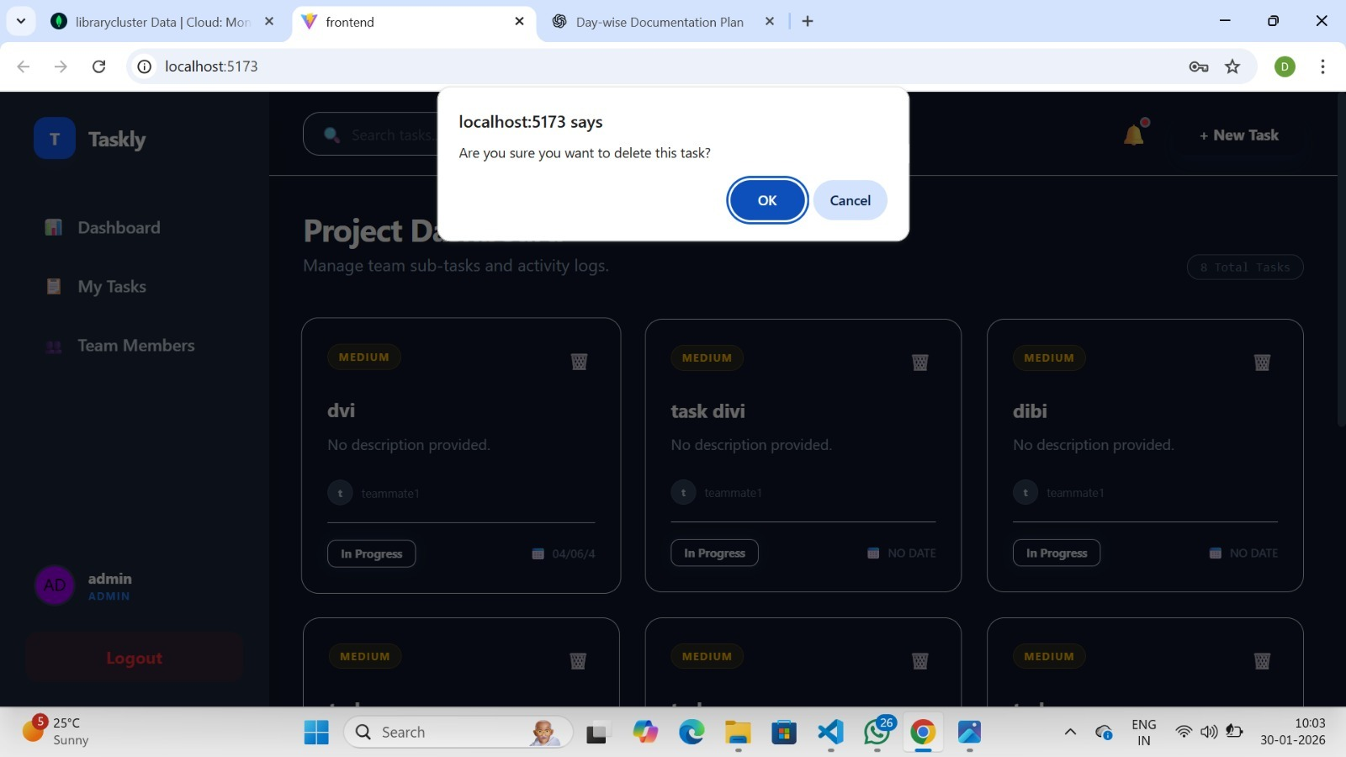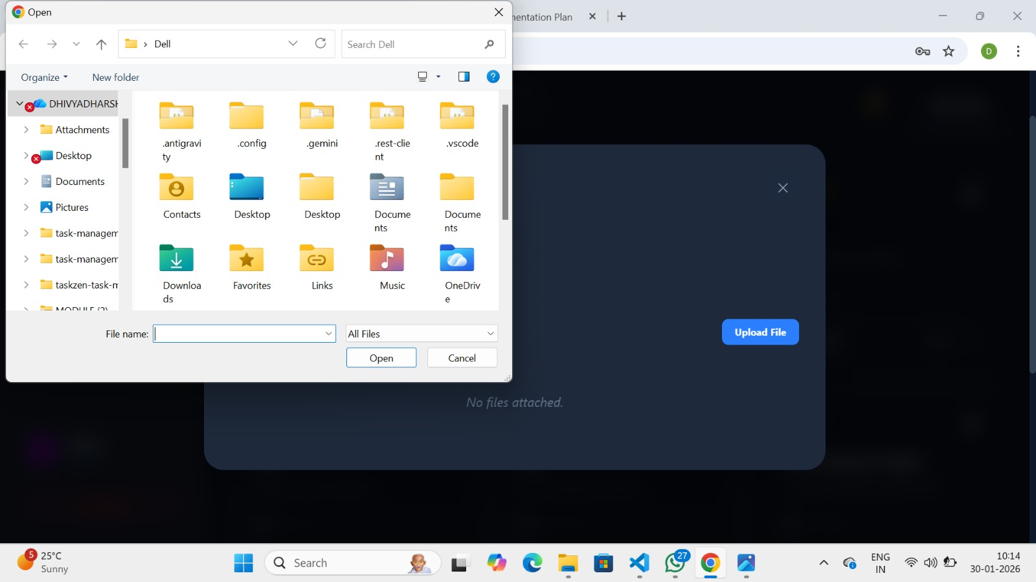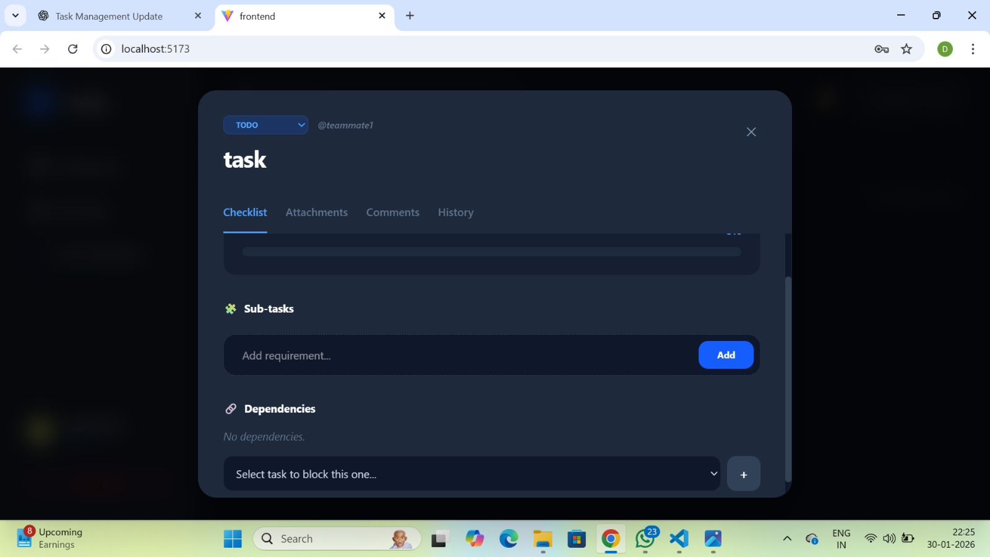
Description:
Completed the task creation feature. The task detail view now includes a checklist section with progress tracking, subtasks, and dependencies, along with an attachments section — both are functioning correctly. Subtasks and dependencies can be assigned and managed only by the admin, while teammates can view them. Assigned tasks are visible only to the respective teammates after login, so each user sees only their own tasks on the dashboard. Tasks can also be deleted by the admin when required.

